UI Design for Day Planner Project

Dated: September 24, 2023

UI stands for User Interface. It's like the way you interact with a computer, phone, or any device. It includes all the things you see on the screen, like buttons, icons, and menus. So, when you click or tap on something, that's part of the UI. It's designed to make it easy for you to use the device or software. Think of it as the bridge between you and the machine!  
  
Here, we have tried to include simple ui by taking the reference of Google Workspace.

The User Interface (UI) of Google Calendar is designed to help you manage your events, appointments, and schedules.

1. Calendar View: When you first open Google Calendar, you'll see the calendar view. This displays the days of the month or week, depending on your selected view. Events and appointments are shown as colored blocks.
2. Navigation Bar: At the top left, there's a navigation bar with buttons like "Today," "Day," "Week," "Month," and "Year." These allow you to quickly change the view to see your schedule in different time frames.
3. Date Selector: On the top left, you can click the date to bring up a date picker. This lets you jump to a specific date quickly.
4. Create Event: There's usually a "+ Create" button or a "Create" button, depending on the version. Clicking this allows you to add a new event or appointment to your calendar.
5. Event Details: When you click on an event, a window pops up showing the details like the title, date, time, location, and any notes you've added.
6. Settings and Options: Clicking on the gear icon or your profile picture in the top right corner opens a menu where you can access settings, manage calendars, and navigate to other Google services.
7. Agenda View: In addition to the calendar view, there's usually an "Agenda" view that lists your upcoming events in a chronological list.
8. Calendars Sidebar: On the left side, you'll find a list of your calendars. You can toggle them on and off to show or hide events from each calendar.
9. Search Bar: There's a search bar at the top where you can search for specific events, calendars, or people you've shared calendars with.
10. Quick Add: Some versions of Google Calendar have a "Quick Add" feature. You can type a natural language description of an event (like "Meeting with John tomorrow at 2pm") and it will create an event based on your input.
11. Google Calendar's UI is designed to be intuitive and user-friendly, making it easy to manage your schedule and events efficiently. It provides a clean and organized layout, allowing you to focus on your agenda without unnecessary clutter.

Lets see the different ui design of Google Calender:  
1. Web View:

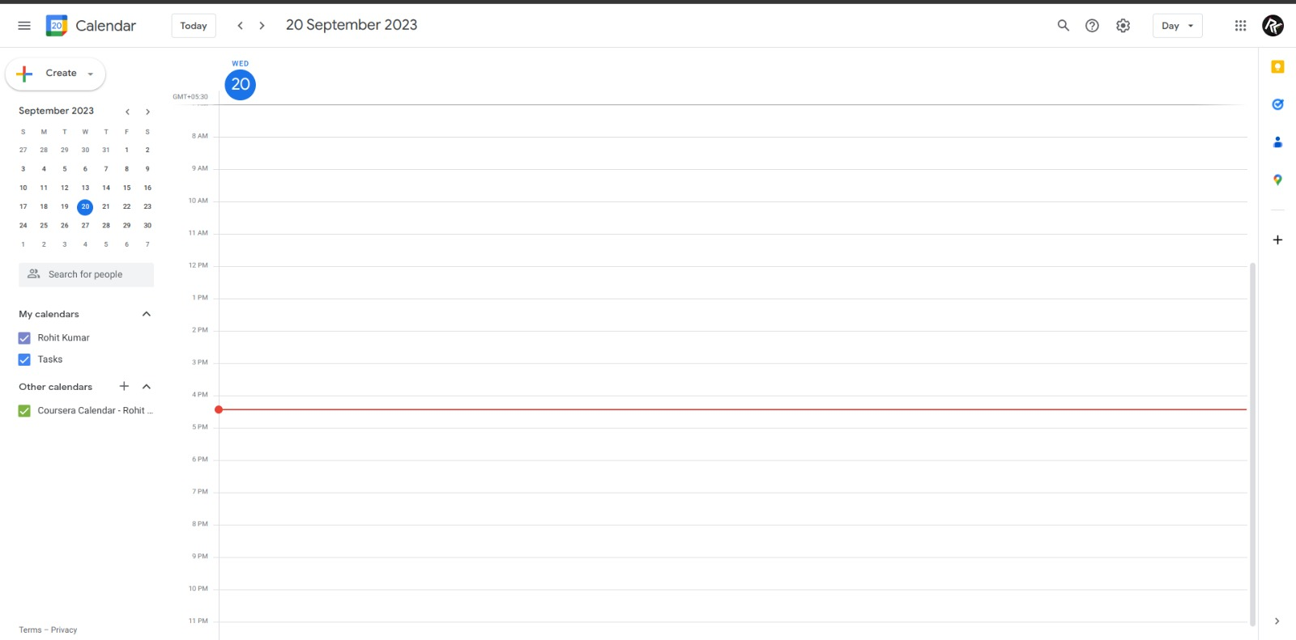

1. 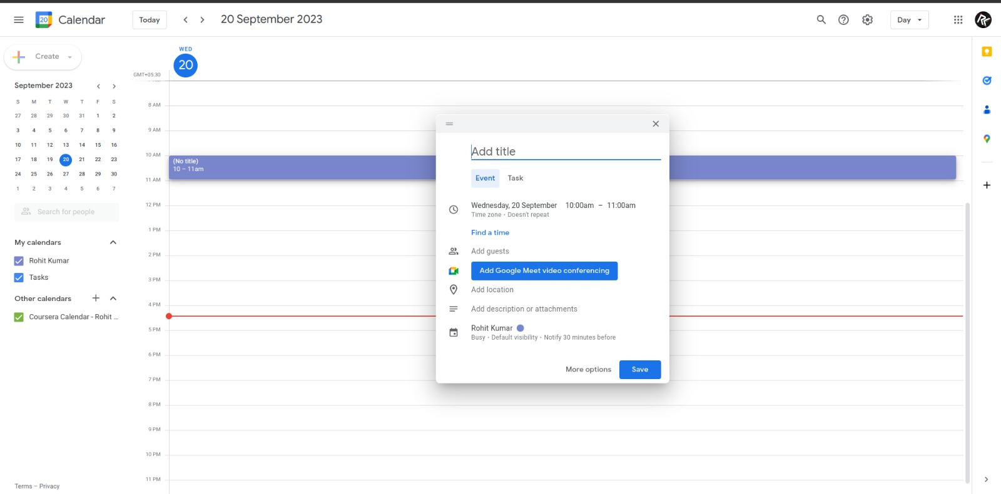Responsive Design: The web view of Google Calendar is designed to be responsive, adapting to different screen sizes and orientations.
2. More Detailed Options: Due to the larger screen space, you might find more detailed options and settings available in the web version compared to the mobile apps.
3. Context Menus: Right-clicking or long-pressing items in the web version often reveals context menus for additional actions.
4. Keyboard Shortcuts: The web version may offer keyboard shortcuts for power users to navigate and interact quickly.

Android Design:

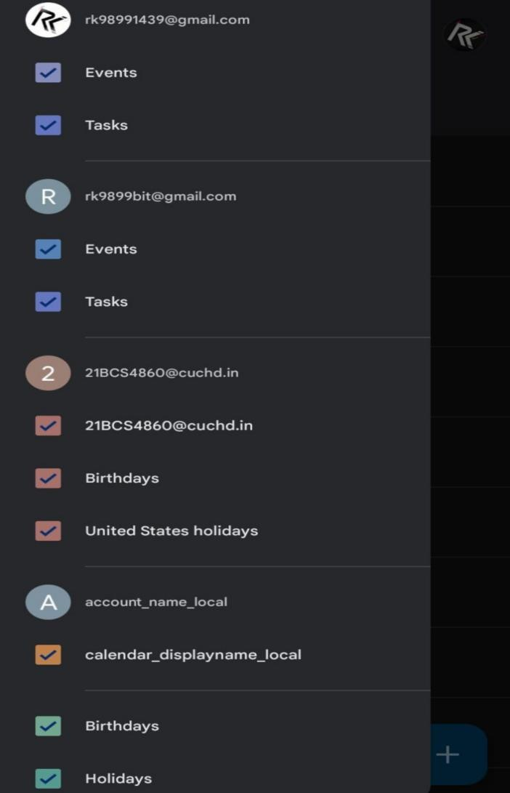

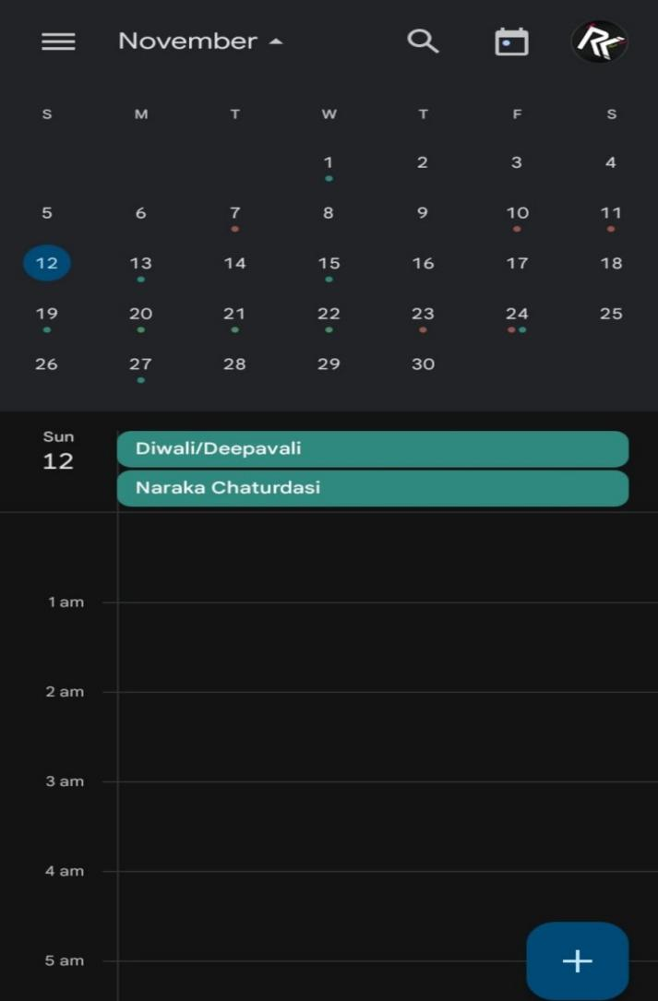

1. Material Design: The Android app follows Google's Material Design guidelines, characterized by a clean, intuitive interface with vibrant colors, subtle shadows, and smooth animations.
2. Navigation Drawer: It typically features a navigation drawer on the left side, which allows users to switch between different views (day, week, month, etc.) and access settings, calendars, and other options.
3. Floating Action Button (FAB): There's usually a FAB at the bottom-right corner for creating new events quickly.
4. Integration with System Features: Android's deep integration allows features like Google Assistant to easily interact with the calendar app.
5. Widget Support: Android allows users to place a widget on their home screen for quick access to upcoming events.

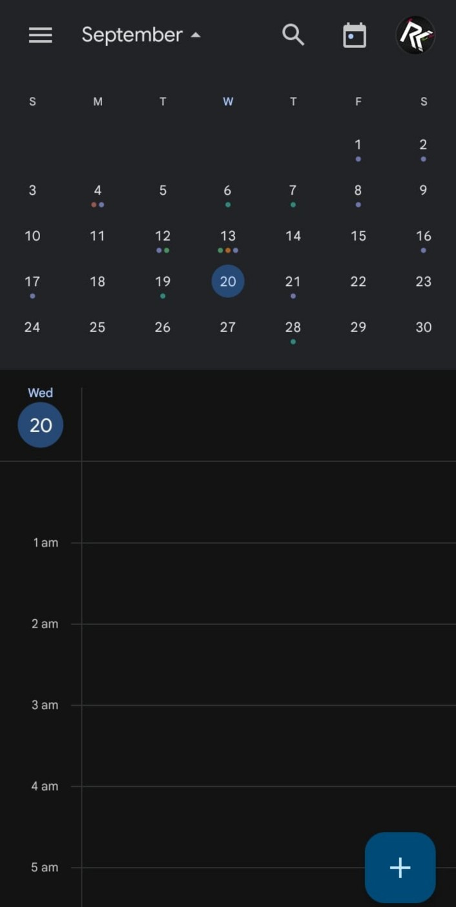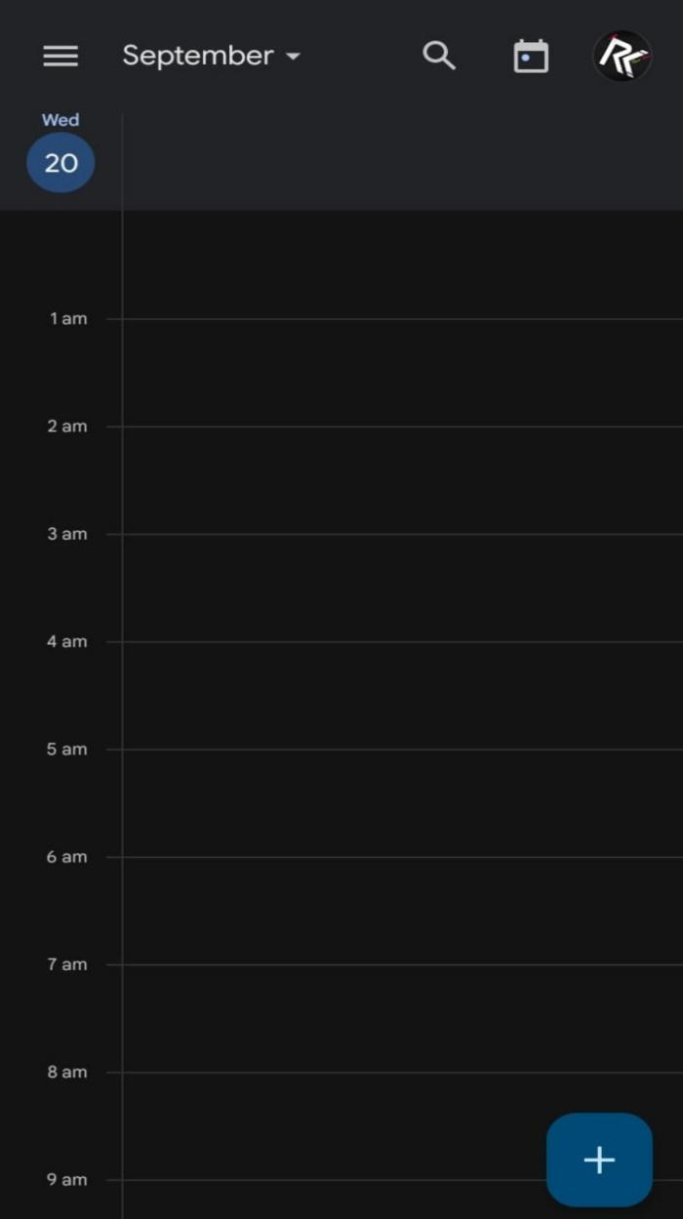

1. IOS Design:

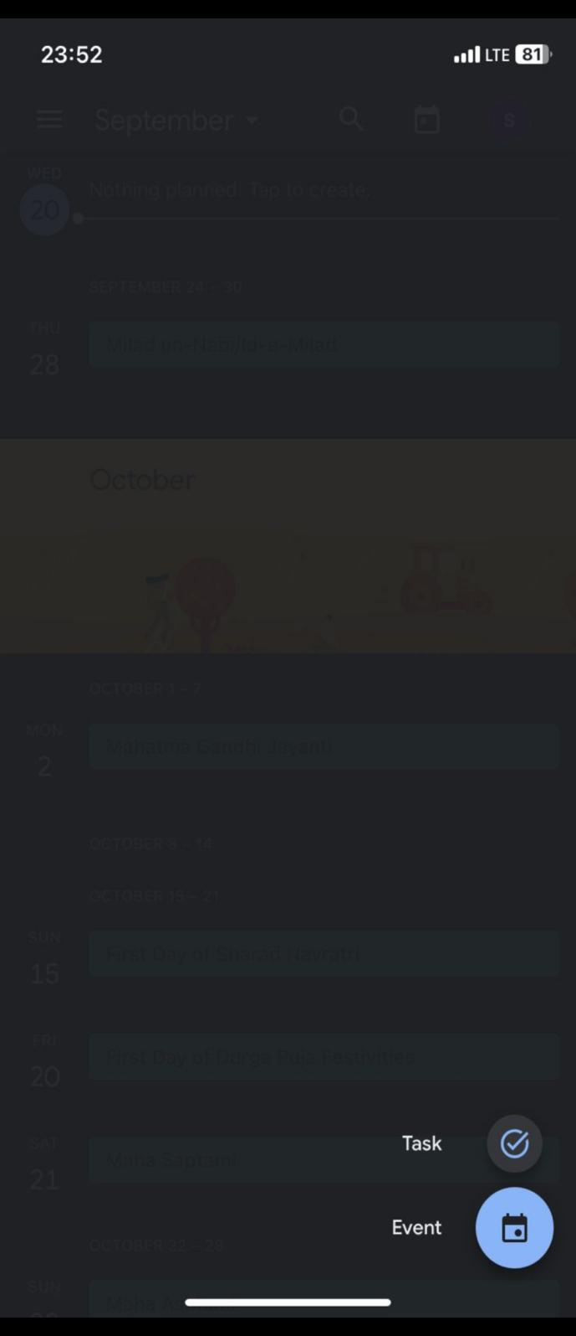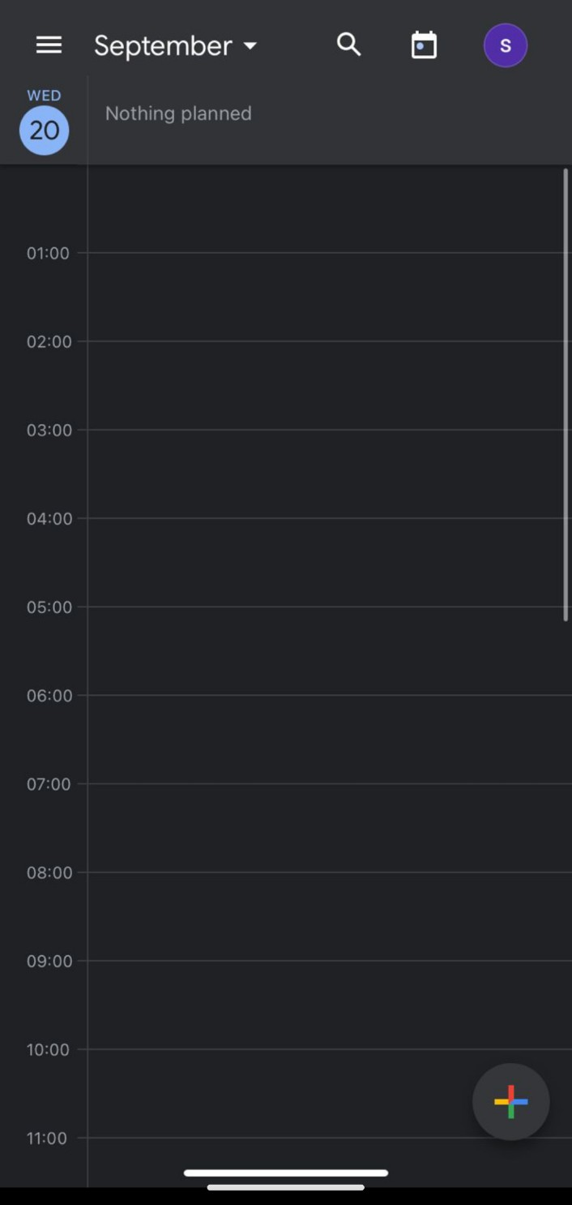

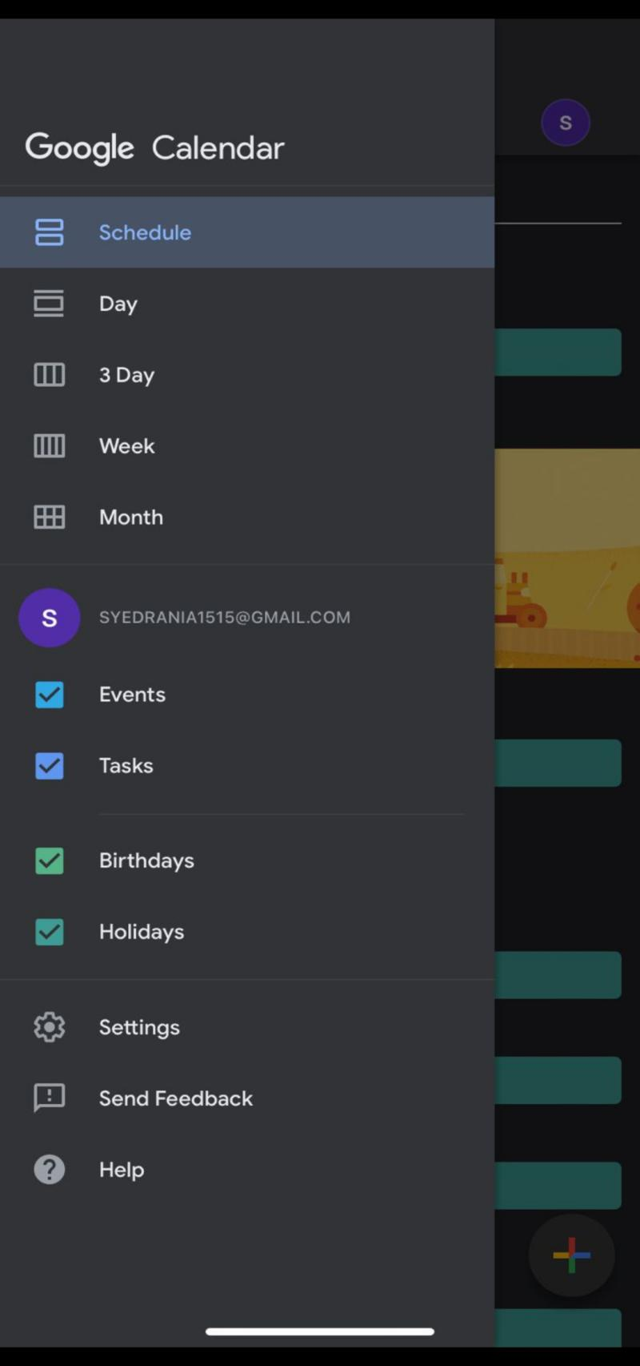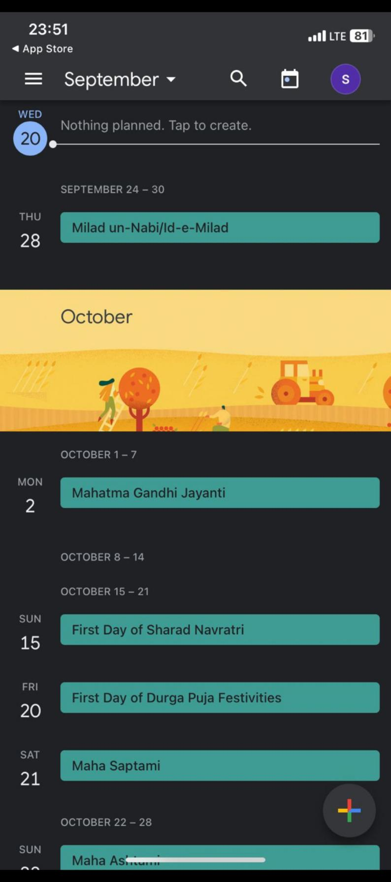

1. Responsive Design: The web view of Google Calendar is designed to be responsive, adapting to different screen sizes and orientations.
2. More Detailed Options: Due to the larger screen space, you might find more detailed options and settings available in the web version compared to the mobile apps.
3. Context Menus: Right-clicking or long-pressing items in the web version often reveals context menus for additional actions.
4. Keyboard Shortcuts: The web version may offer keyboard shortcuts for power users to navigate and interact quickly.  
     
   Conclusion:  
   We are trying to make our application cross platform i.e, it will have same interface everywhere to ensure uniformity.  
   This will slow down the learning process of end user and need not to get familiar on multiple platforms.  
   Maintaining the simple user interface as exists before will catch more users to use our app.